Open Meduas from Applications in Kali Linux.

Get IP address of Metasploit 2 by typing if config.

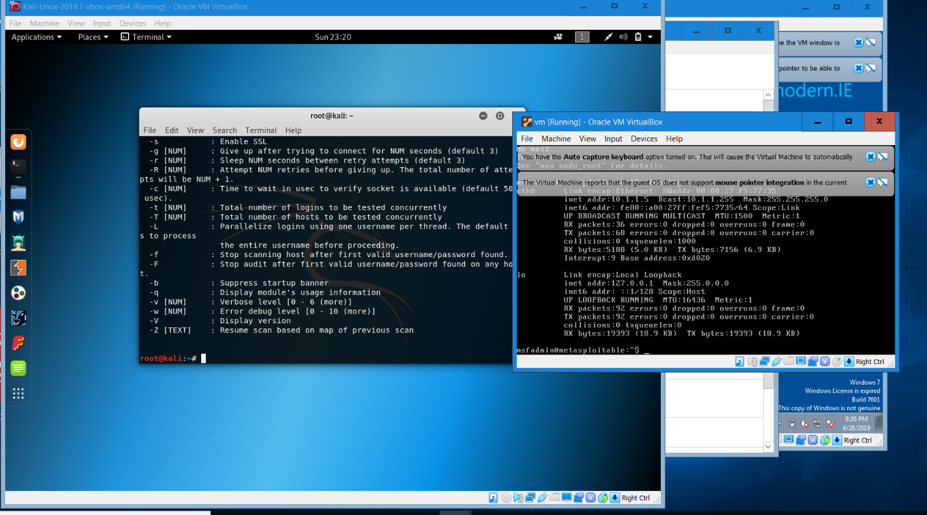

Attempt to run brute force attack on medusa; Attack failed because there wasn’t a wordlist file in the directory.

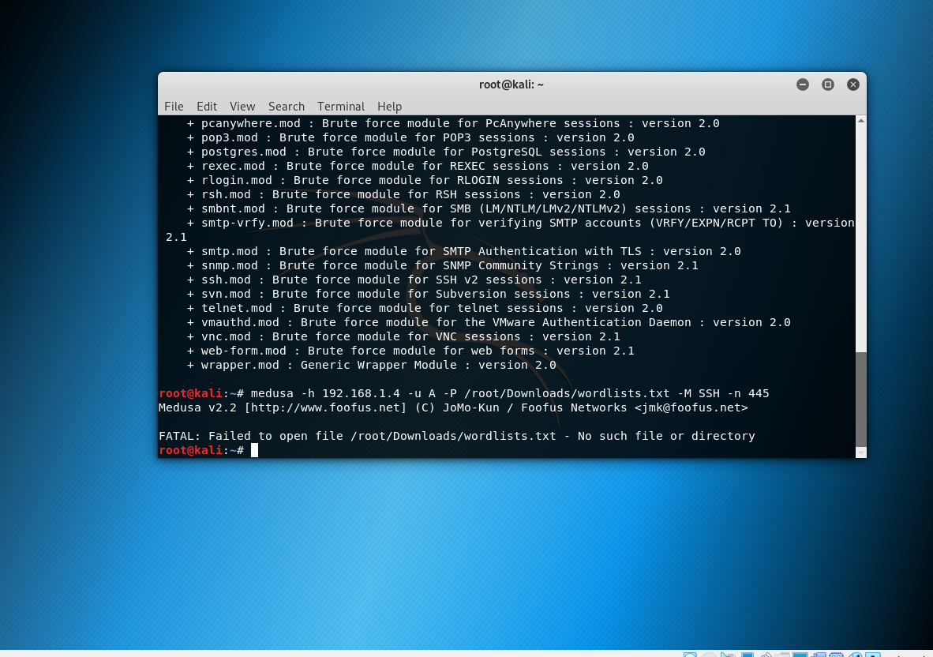

Tried another application called Hydra.

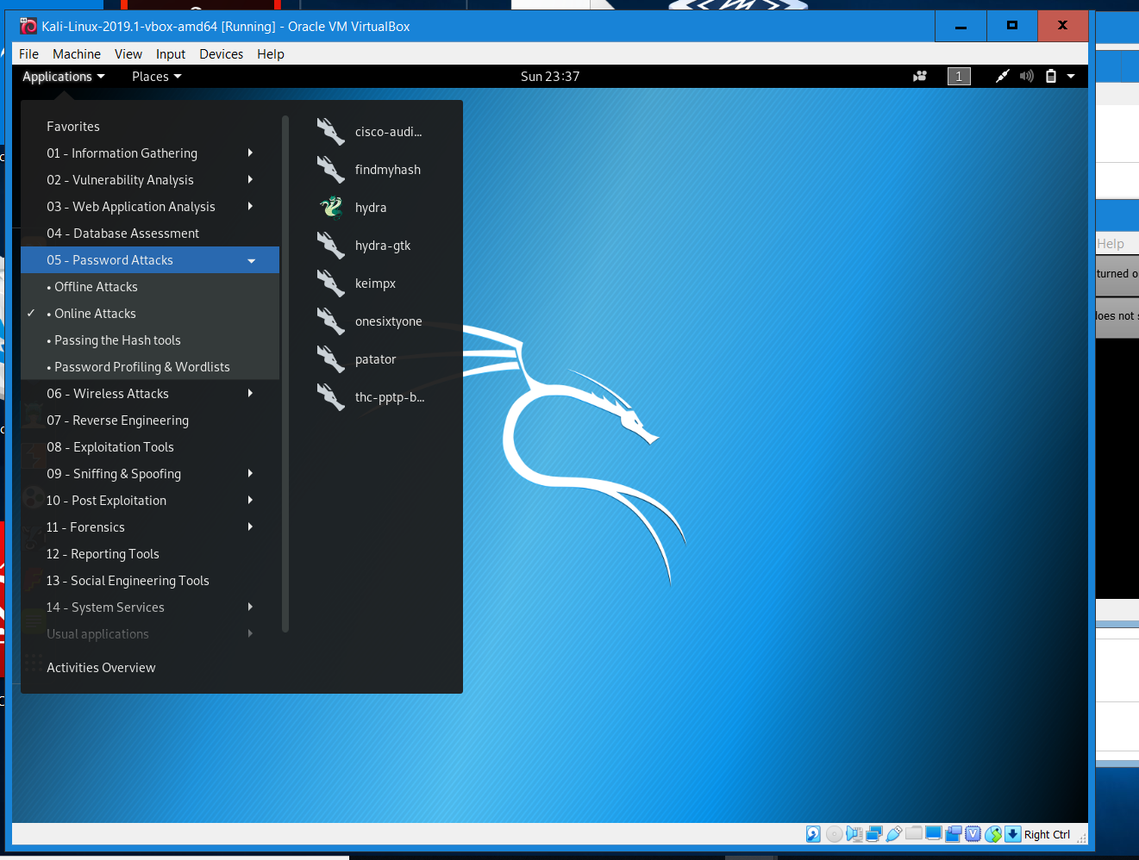

Attack successful; didn’t find any valid passwords.

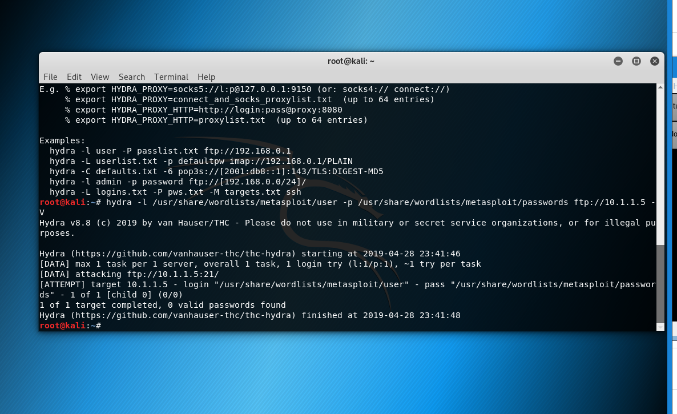

Tried Rainbow Crack Application. No results returned. Realized that I needed to create a wordlist document.

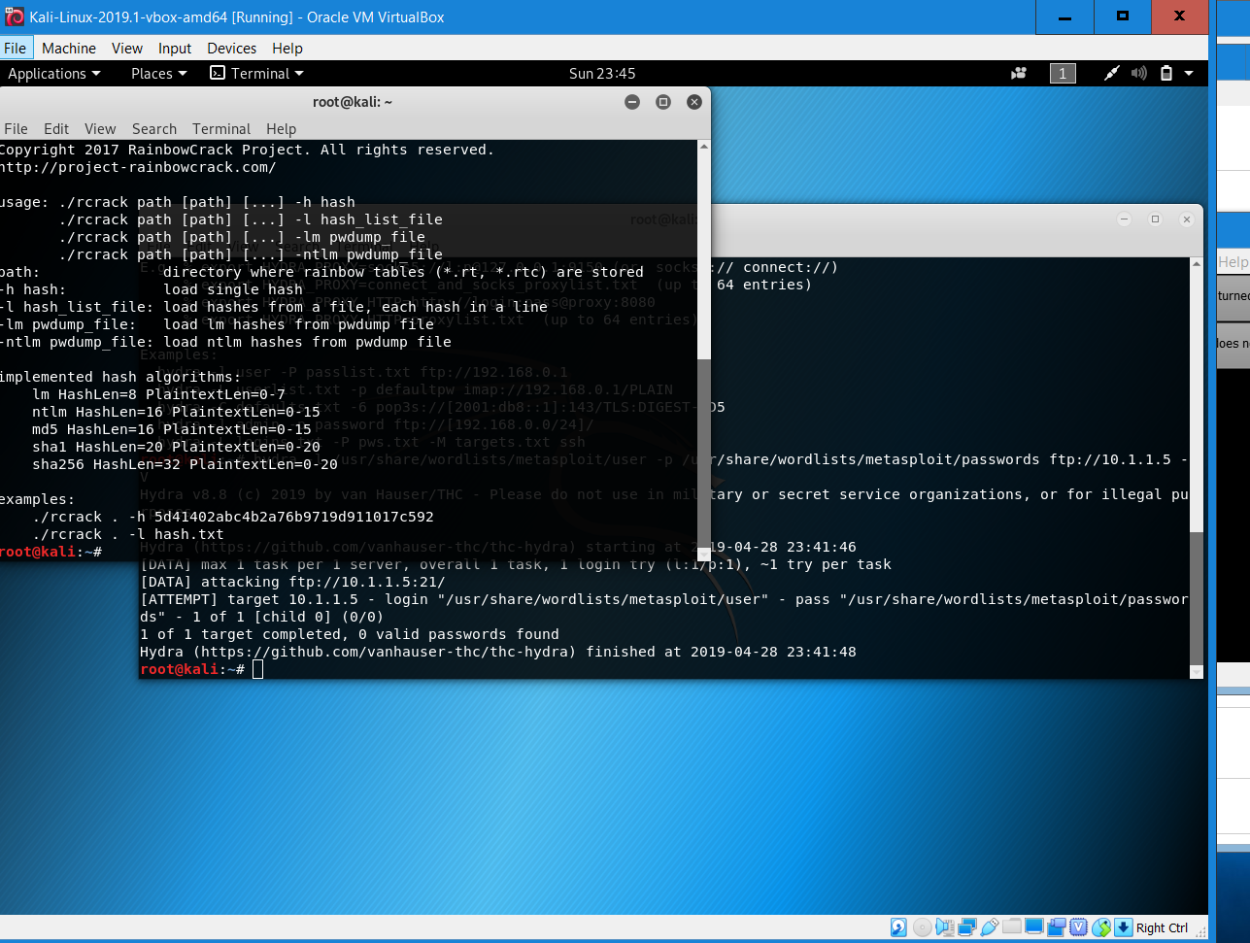

Analysis

I searched the internet for a tutorials describing the brute force process using Kali Linux. I came across a tutorial on yeahhub.com titled Brute force password cracking with Medusa.

This would be my first-time utilizing Medusa for password cracking. Medusa is a fast-paced password cracker. The application is pre-installed in all Kali Linux software. It can be accessed by typing Medusa in the terminal.

I ran an ifconfig command on Metasploitable 2 to get the IP address. I needed it to begin the brute force process in Medusa.The attempt failed because the application could not find the wordlist.

I assumed that this was just a machine error, so I tried Hydra, and rainbow cracker. The results were no different. Soon after I realized I should have created a wordlist. The attack would have been successful If that step was not missed.

Opened Hashcat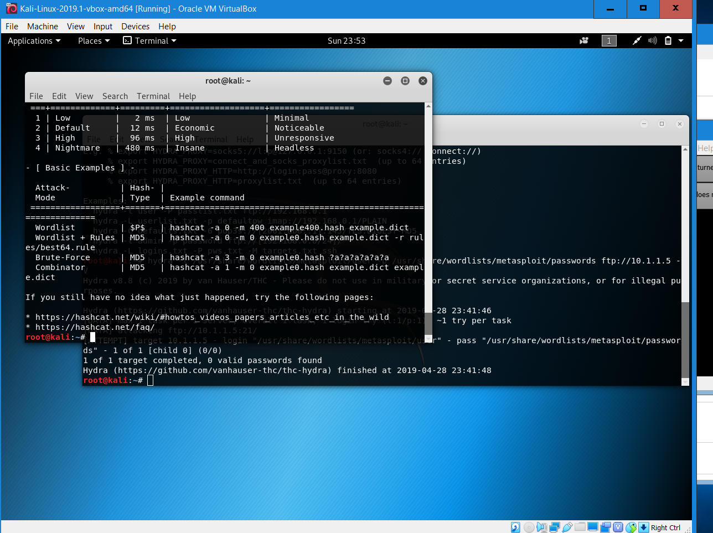

Ran wordlist in hashcat

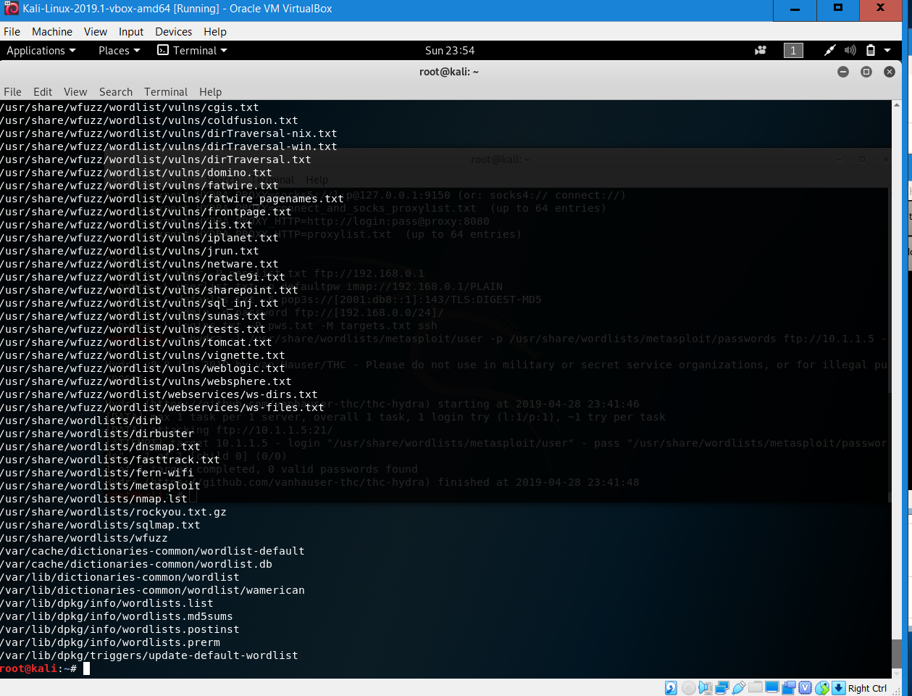

Search for shadow file

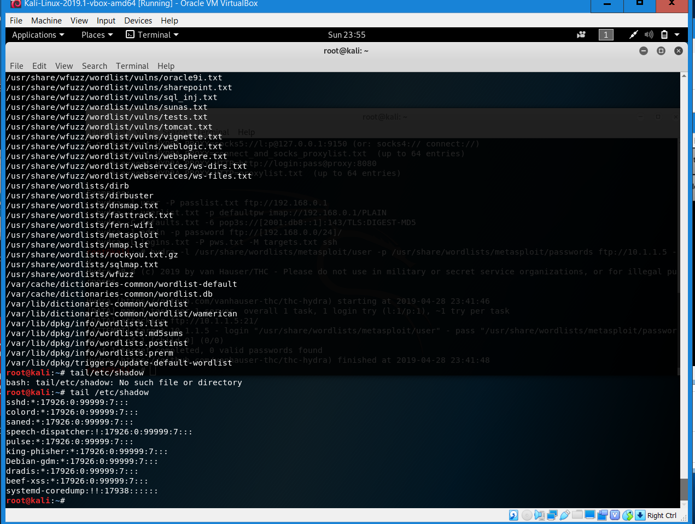

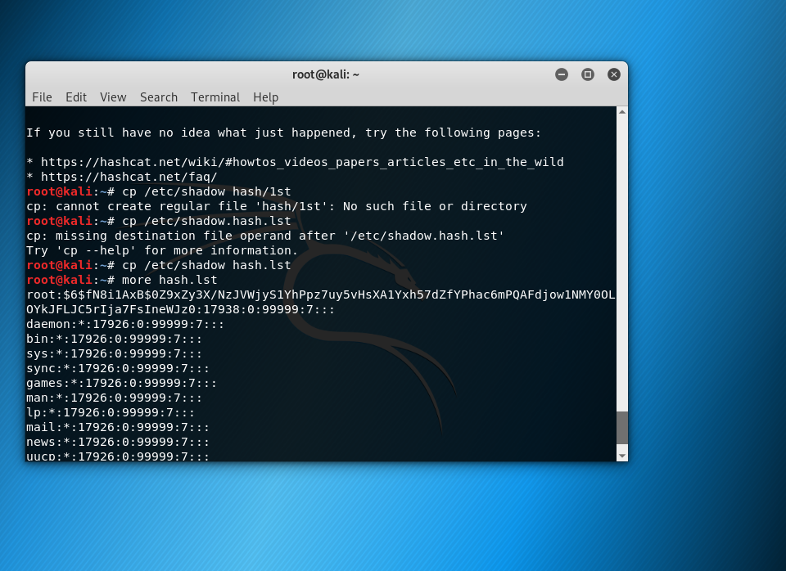

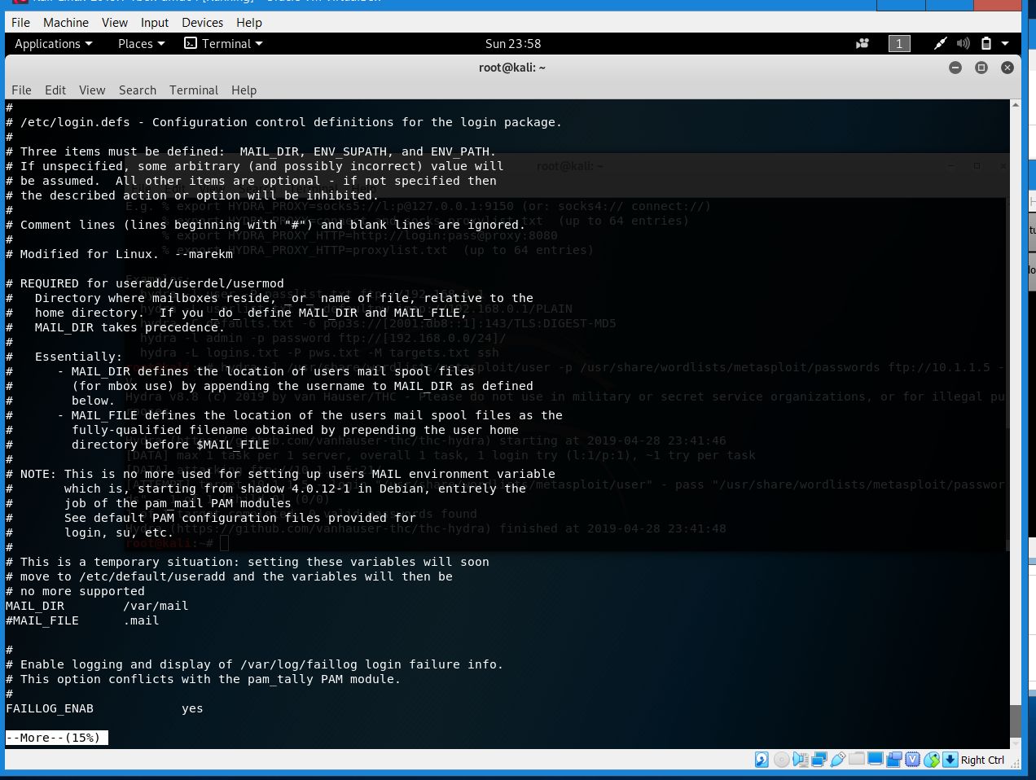

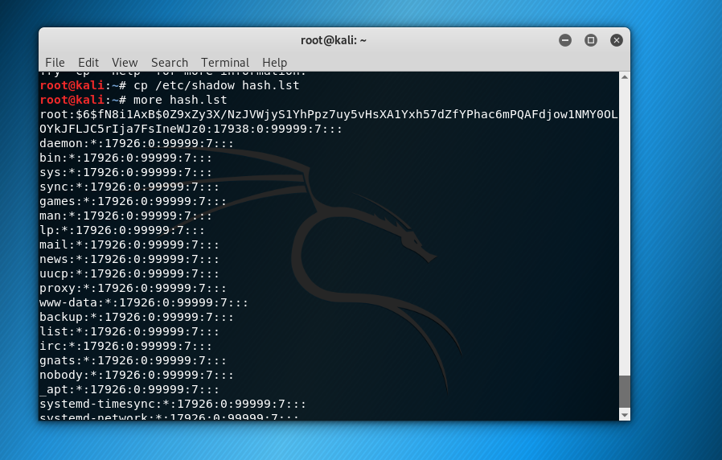

Unable to retrieve cracked password list

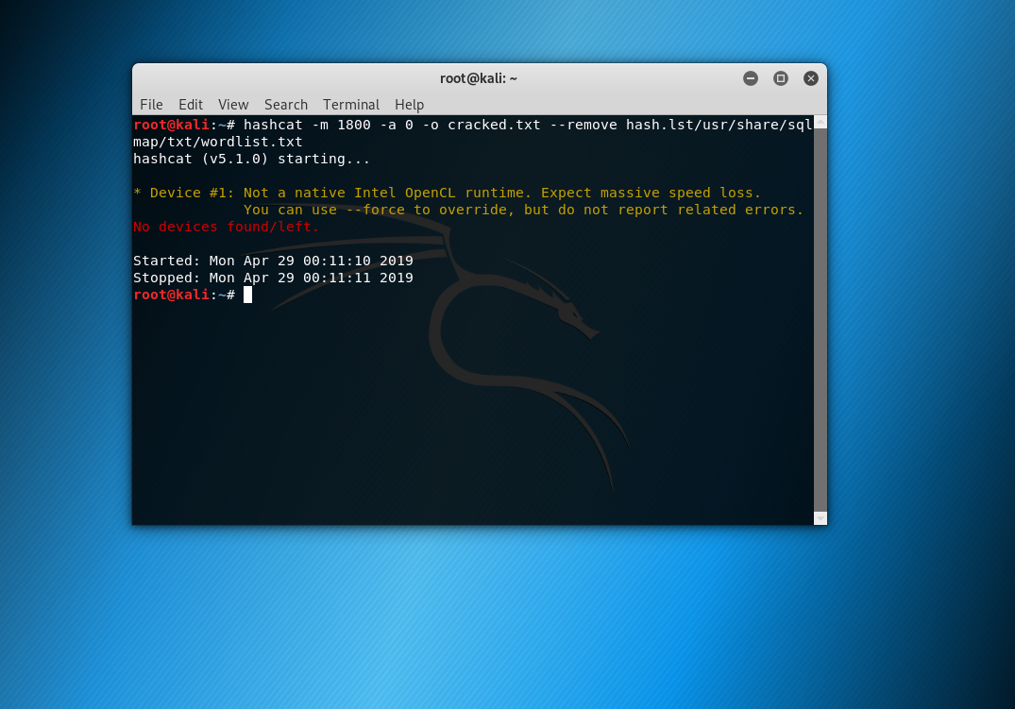

For this part of the assignment I followed along with the online tutorial. I used hashcat password cracker. I searched the wordlist and verified that they were stored on the computer. I found the document on the system and used text editor to edit it. After editing it, I tried to use run the password cracker command in hashcat but I was unsuccessful.